EJERCICIOS NFS

1-

#Carpeta server
sudo mkdir /smlshared
sudo chown nobody:nogroup /smlshared
sudo chmod -R 777 /smlshared
sudo echo "/smlshared *(ro,no_subtree_check)" >> /etc/exports
sudo systemctl restart nfs-kernel-server.service

#Ip
sudo cp /etc/netplan/00-installer-config.yaml /etc/netplan/00-installer-config.old
sudo nano /etc/netplan/00-installer-config.yaml

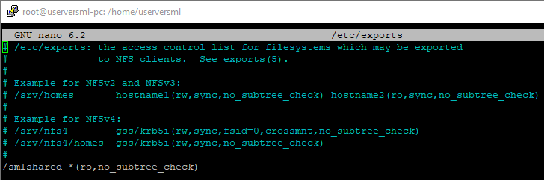
2-
#Host
sudo apt install nfs-common
sudo mkdir -p /mnt/nfs/smlshared
sudo chmod -R 777 /mnt/nfs
sudo chown nobody:nogroup /mnt/nfs/smlshared
sudo mount 192.168.^.^:/smlshared /mnt/nfs/smlshared
#Añadir "192.168.^.^:/smlshared /mnt/nfs/smlshared nfs auto,noatime,nolock,bg,nfsvers=3,intr,tcp,actimeo=1800 0 0" » /etc/fstab
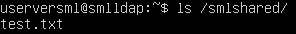

3-
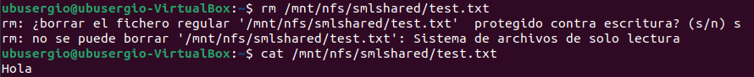
No deja eliminar el archivo ya que solo esta compartido con permisos de lectura(ro)
4-
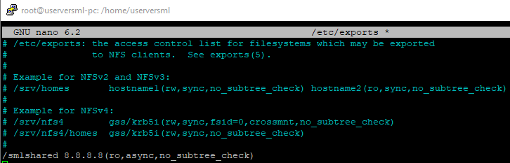
5-

